

Automated Scalable Indoor Garden

Eric Velazquez
David Rooney
Steven Lo
Antonio Orosa

(no sponsors at this time)

Initial Project and Group Identification Document
2. Project Description

This project is a scalable indoor garden with sensors that detect light, air, and water, and will automatically adjust the environment to the appropriate levels to ensure an ideal environment for the plants inside. The system will be enclosed in a cabinet sized container, allowing it to be moved to different locations. The system will monitor power consumption and be scalable. The number of plants inside depends on plant size and structure (bushy, tall, fast growing, multiple cycles).

Lights will consist of low power LED grow lights that are timed based on the plant and plant cycle. The number of lights depends on the number of plants and the intensity of light desired. The intensity of the light will determine the distance between the bulbs and the plants canopy. LED lights will also provide low heat output, assisting in controlling the environment.

Air quality will be tested using multiple sensors including: temperature, humidity, and CO₂. Adjustments to the environment will be automated, viewable from a web/mobile app and adjusted if the user wishes. With the lights in the system on, temperatures are expected to increase. To bring the temperatures back to desired levels, warm air will be cycled out and fans will turn on providing a breeze. Humidity levels will be adjusted according to the plants needs and a humidifier will provide more air moisture for the plants. As the temperatures and humidity levels adjust, CO₂ levels will also change. A CO₂ sensor will detect whether the environment needs adjusted CO₂ levels. A CO₂ tank will then pump small amounts of CO₂ until the desired level is reached.

Water supply depends on whether the user decides to use pot and soil or a hydroponic system. In soil a plant must be monitored and watered regularly. Moisture levels will be monitored and controlled; if low, the system will then water the plants using a water pump and a series of tubes connected to a reservoir that is monitored to assure the water has the correct water quality (pH level, temperature). An added feature would be a nutrient pump that will mix with the water coming from the reservoir to supply the plant with nutrition if needed. Fertilizer in the soil could eliminate this feature.
A hydroponic system replaces the soil with water, allowing the plant’s roots to grow directly into the water. This allows for more control of what the plant is being fed (nutrients). A separate reservoir, filled with pH-balanced water as well as liquid nutrients and an air pump to supply oxygen, cycles water through the plants root system. With the right conditions the plant will be receiving the nutrients it needs at the optimal level. The water’s temperature, electric conductivity, and pH are monitored and adjusted as the system cycles this water to and from the plants.

2.1 Statement of Motivation
Our cabinet will focus on a hydroponic system. With the automated features, low power, and less water usage our cabinet can grow specific plants in areas where they would not be able to thrive. For example, hot and dry areas are not a great place for tomato since the humidity required for them to flourish can be up to 80%. Also with limitations to irrigation in most states, if it doesn't rain an outdoor garden may go un-watered for up to 3 or more days.
With these features, a user can choose from a database the plant they would like to grow and the system will handle the rest with minimal maintenance from the user. List of things system cannot do that the user must: refilling the water tank, refilling liquid nutrients, replacing or repairing parts.

3. Specifications and Requirements

Sealed cabinet enclosure, approximately 6 feet tall, with a reservoir underneath containing 10-15 gallons, movable with wheels. Cabinet will open with minimal effect on the inside environment allowing access to the plants and components.

Water System
- The ideal pH range for most hydroponic plants is between 5.5 and 6.5. The pH sensors must be able to monitor the pH levels in the water so that it can communicate to the system to add a small amount of acid or alkali in order to restore the proper pH level. If we use pH Up and pH Down to help adjust the pH, our system should only need 1ml-2ml of pH Up/Down per gallon of water. After adjusting by adding only 1 or 2 ml at a time, the system will wait 15-30 minutes to check again before making additional adjustments.
- EC sensors will be able to indicate when the Nitrogen and/or Phosphorous levels are too high or too low. The system will be able to respond to this information by adding water when nutrient levels are too high, or adding nutrients when the levels are too low. This feedback control system will ensure that the plants receive the optimum level of nutrients. Next to our pump and water reservoir will be a nutrients reservoir that can be injected into the water to give the plants the right mixture they need. Different species of plants will need differing levels of nutrients. Our system will be able to make various mixtures, depending on the plant used.
- Water Level: The unit must be able to send notification for the user to refill the water when water reservoir is low. The system should also be able to tell when the water level is rising too high, so that it will not overflow as it corrects itself for off-balance nutrient levels. Our unit should also be designed to have the proper amount of water pressure to ensure that the pump can provide every plant with the enriched water that it needs.
- Physical Hydroponic System: Our configuration will be set up in such a way that keeps each row of plants slightly slanted. This will put the forces of gravity to work for us, and will aid in drainage during the low-tide part of the plant's water cycle. Our pump must be strong enough to push the water up from our reservoir to reach the top plants, and the pump must use minimal energy in its process so that the total power usage stays low.
- Oxygen stone will be placed in the water reservoir in order to keep the water oxygenated and will also aid in the mixing of the nutrients.

Environment
- Temperature will be kept within 70-85 degrees (dependent on plant type)
- C02 will be kept from 1100-1300ppm (dependent on plant type)
- Humidity will be 20%-100% (dependent on plant type)
To mimic the sun and the season changes, we will be using LED lights at certain wavelengths that provide the plant with the spectrum it needs. (REDS 630nm-660nm, BLUES 430nm-460nm). Light cycles are controlled to simulate day and night. The lights will also be interchangeable and range from 15Watts-150+Watts.

Ventilation (HVAC)
The cabinet will need to be cooled and warmed when needed. A ventilation system will cycle inside air out and draw in air from the room it is in, through a filter. Small fans will also be controlled to keep air circulation inside.

4. Block Diagrams

Below are the block diagrams of our hardware and software components. This section will also provide a brief description for the purpose of each item and explain how the system is fully connected.
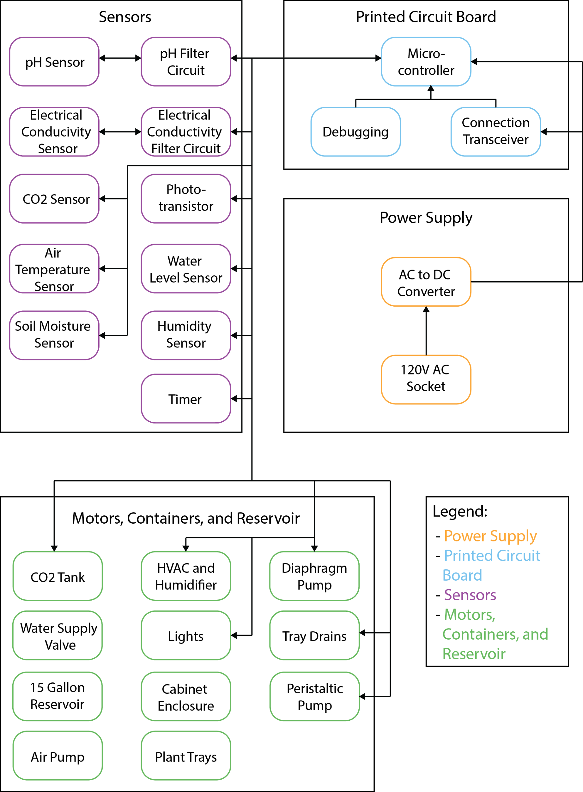
Figure 1: Hardware Block Diagram

There will be many hardware components that go into the construction of this project. The table below (Table 1) shows every individual block in Figure 1 delegated to a member of the team who is responsible for overseeing the function and mechanism of that piece of hardware.

David | Steven | Eric | Antonio
Connection Transceiver | Microcontroller | Printed Circuit Board (wiring) | Power Supply (converter)
Microcontroller | Phototransistor | pH Sensor | Printed Circuit Board (wiring)
Soil Moisture Sensor | Air Temperature Sensor | pH Filter Circuit | pH Filter Circuit
Timer | Humidity Sensor | Electrical Conductivity Sensor | Electrical Conductivity Filter Circuit
Diaphragm Pump | Timer | Electrical Conductivity Filter Circuit | CO₂ Sensor
Tray Drains | Tray Drains | HVAC and Humidifier | Water Level Sensor
Cabinet Enclosure | Lights | Diaphragm Pump | CO₂ Tank
15 Gallon Reservoir | Air Pump | Peristaltic Pump | Water Supply Valve
Plant trays | Plant trays | Lights | Cabinet Enclosure
Table 1: Hardware Maintenance Responsibilities
To start with, the power supply that the user will be using is an electric 120V AC socket from their wall. This will be connected to an AC to DC converter which directs the current to our printed circuit board, lights, air pump, diaphragm pump, humidifier, and peristaltic pump. Once the system is powered up, the user is able to use the sensors to control the environment and the water in the reservoir. The sensors are wired to the circuit board which triggers a certain function to turn on. For instance, the pH level in the reservoir can be too acidic, prohibiting the plants in the environment from receiving the right water quality they need to grow. In this case, the pH sensor will trigger the circuit filter and use the peristaltic pump to release nutrients and chemicals into the reservoir to stabilize the water to its optimal condition. The rest of the sensors attached to the circuit board will work identically as the pH sensor, keeping the environment and water in near perfect condition. The plant trays and cabinet enclosure is the infrastructure of this entire system. The cabinet enclosure acts as the case of the environment, holding all of the equipment, electronics, sensors, hardware, etc. The plant trays will be inside the enclosure and will hold the plants in them. These trays will also be scalable, satisfying different shapes and sizes of plants.

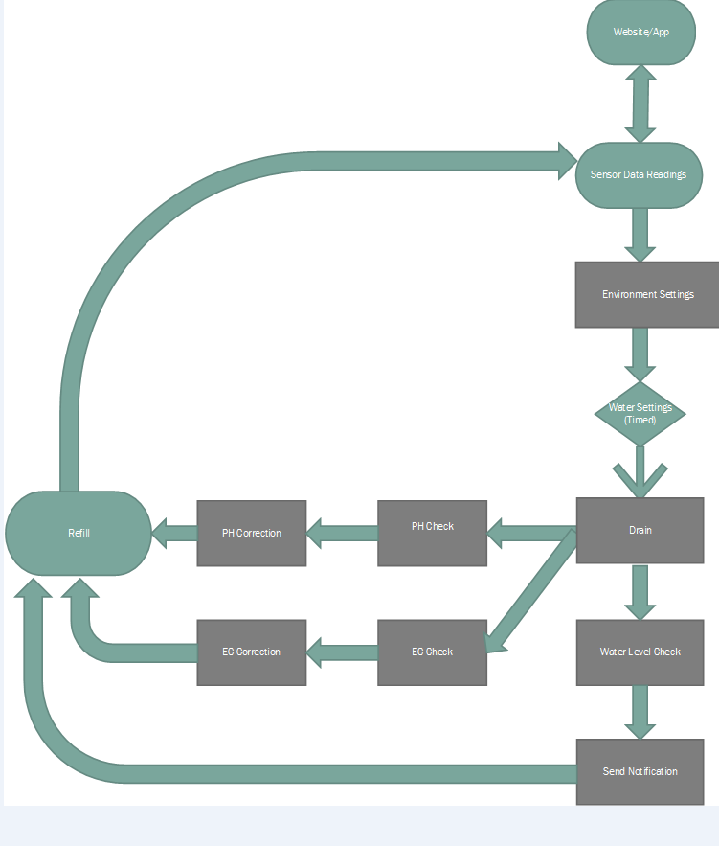
Figure 2: Software Block Diagram for Water Subsystem

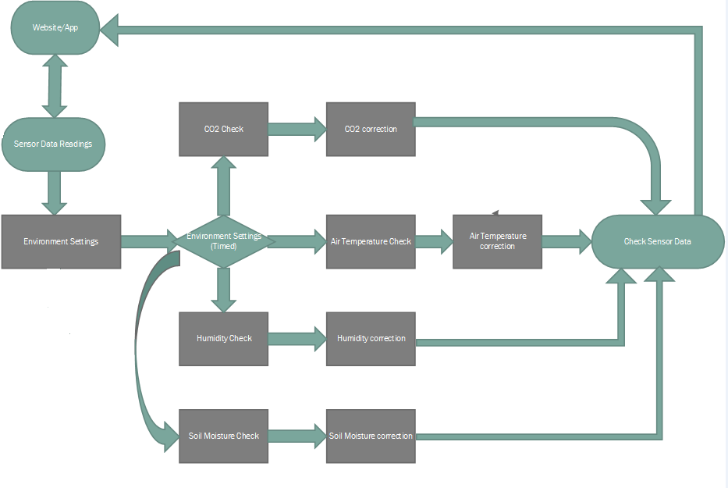
Figure 3: Software Block Diagram for Enclosed Environment

5. Budget and Financing

The project budget, so far, will be determined based on the system we choose to accomplish in this project (hydroponics or soil). In the hydroponics system, we have to account for the pH sensor and filtering circuit, the electrical conductivity sensor and filtering circuit, the peristaltic pump, air pump, and all of the necessary tubes, wires, and chemicals associated with each component. Many of the components used in the soil-based system will be integrated into the hydroponic system. The only sensor we can subtract from the expenses will be the soil moisture sensor. Also, with the hydroponics system, note that not only does this mark up the cost of the system as a whole, but also increases the maintenance cost for the user. The other option is the soil-based system. In this system, we save money on excess water features and technology, and focus more on the air environment the plants are growing in. In going this route, the largest expenditure will be the CO₂ sensor that will be placed inside the enclosure. Below are tables (Table 2 and Table 3) showing the variables in each system and the difference in cost between both options.

Soil System
Product |  |  | Price
Phototransistor |  |  | $1.00
Air Temperature Sensor |  |  | $4.00
Water Level Sensor |  |  | $6.00
Humidity Sensor |  |  | $4.00
Soil Moisture Sensor |  |  | $12.00
CO₂ Sensor |  |  | $60.00
Other Supplies & Hardware |  |  | $100.00
 |  | Total | $187.00
Table 2: Soil System
Hydroponics System
Product |  |  |  | Price
pH Sensor |  |  |  | $35.00
pH Filter Circuit |  |  |  | $10.00
Electrical Conductivity Sensor |  |  |  | $100.00
Electrical Conductivity Filter Circuit |  |  |  | $10.00
Peristaltic Pump |  |  |  | $15.00
 |  |  | Subtotal | $170.00
Soil System minus Soil Moisture Sensor |  |  |  | $175.00
 |  |  | Total | $345.00
Table 3: Hydroponics System
5.1 Sponsorships and Funding
At this time, we are in search of third party funding and sponsorships. So far, we have reached out to light (LED) companies, soil sensor companies, and water quality companies to supply us with specific products that relate to our goals and objectives for this project.

6. Project Milestone

This spring semester, our objective is to finish the complete design of the system. We want to ensure that every component is accounted for in our design before moving on with the implementation. During the design phase is a great time for us to order some of the products that we plan to use in our system. This will allow us to get accommodated with products going into our system and test the accuracy of the component. Some of the specifics of our design phase include:
- The drawings and architecture of the cabinet and enclosure
- The placement of the larger hardware in the cabinet, such as, the reservoir and the multiple pumps that will go into our system
- The placement of the smaller hardware, such as, the electronics, the sensors, the lights, the tubes and wiring, and the trays for the plants
- The cost of each item and how it affects the cost of our system
- The software platforms that will be used in the back end and front end
The design phase will be a lot of trial and error, and redesigning of our system. Not everything will work right out of the box and we plan to make adjustments where necessary. Closer to the end of the spring semester, our goal is to have begun building the infrastructure of our system so it will be easier to implement many of the components that are easy to manipulate. For example, having the cabinet built to where we can slide in the reservoir, the plant trays, install the LED lights, and pumps, would be ideal.

The objective in the summer (second semester, design 2) will be to finish modeling the system. This will consist of the wiring of the sensors and motors, the tubing and pipes of the reservoir and pumps, and the software aspect of this system. Once the system is completely built, we will run tests daily ensuring that all functions are in sync and are working correctly, providing us with the result we designed for.

